Tablets for fear of flying: why we don’t prescribe them any more
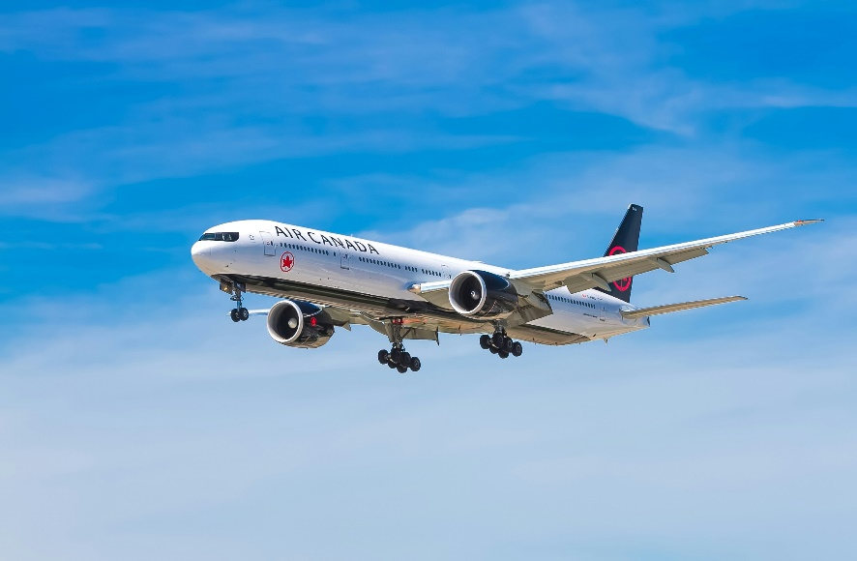
1st MAY 2026
People sometimes ask the doctor or nurse to prescribe Diazepam, or similar drugs like lorazepam temazepam or clonazepam, for fear of flying or to help sleep during flights.
Prescribing these drugs is not recommended any more for these reasons:
1. Although plane emergencies are rare, taking Diazepam reduces awareness and reaction times for patients so you risk not being able to react to save your life if you must escape quickly. You may also put other people in danger by getting in their way or making them help you.
2. The use of these drugs can make you sleep in an unnaturally deep sleep. This means you won’t move around as much as during natural sleep, so you have a bigger risk of getting a blood clot (Deep Vein Thrombosis – DVT) in the leg or lungs. Blood clots are very dangerous and can kill. This risk is bigger if your flight is longer than 4 hours.
3.They have short term bad effects on memory, co-ordination, concentration and reaction times, and are addictive if used for a long time, with withdrawal leading to fits, hallucinations, agitation and confusion. They have also become widely used drugs of abuse since they first came on the market. Diazepam in the UK is a controlled drug. The prescribing guidelines doctors must follow say that that use to treat short-term ‘mild’ anxiety is inappropriate. They are only to be used short term for a ‘crisis in generalised anxiety’. But if you are having such a crisis, you are not likely to be fit to fly. Fear of flying in isolation is not a generalised anxiety disorder.
4. Some people get agitated and aggressive after taking diazepam and similar drugs and behave in a way that they would not normally, which can pose a risk on the plane. This affects everyone’s safety and could get you into trouble with the law. A similar effect can be seen with alcohol, which has led to people being removed from flights.
5. There is evidence use of these drugs stops the normal adjustment response that would gradually lessen anxiety over time, and may increase anxiety in the long term, especially if used repeatedly.
6. Diazepam and similar controlled drugs are illegal in several countries. They may be confiscated, or you may find yourself in trouble with the police.
7. Diazepam stays in your system for some time. If your job or sport needs, you to have random drug testing you may fail this having taken diazepam.
8. It is important to tell your travel insurer about your medical conditions and medications you take. If not, there is a risk of your insurer not paying if you try to make a claim.

So, we will no longer be providing Diazepam or similar drugs for flight anxiety. Instead, please try one of these aviation industry recommended flight anxiety courses.
We appreciate a fear of flying is very real and very frightening and can be debilitating. However, there are much better and effective ways of tackling the problem. We recommend you tackle your problem with a Fear of Flying Course, which is run by several airlines, often exceeding 95% success rates.
These courses are far more effective than diazepam, they have none of the undesirable effects and the positive effects of the courses continue after the courses have been completed.
Easy Jet
www.fearlessflyer.easyjet.com
Tel: 0203 8131644
British Airways
https://www.britishairways.com/en-gb/information/travelassistance/flying-with-confidence
Tel: 01252 793250
Virgin Atlantic
https://www.virginatlantic.com/inspiration/your-journey-with-us/flying-without-fear
Tel: 0344 874 7747

